

RAJALAKSHMI INSTITUTE OF TECHNOLOGY
(An Autonomous Institution, Affiliated to Anna University, Chennai)

DEPARTMENT OF ARTIFICIAL INTELLIGENCE AND MACHINE
LEARNING
ACADEMIC YEAR 2025 – 2026
SEMESTER IV
AD23411 – DATA ANALYTICS LABORATORY
REGISTER NUMBER | 2117240030016
NAME | BARATH S
PROJECT TITLE | EMAIL COMMUNICATION NETWORK ANALYSIS
DATE OF SUBMISSION
FACULTY IN-CHARGE
MINI PROJECT REPORT

INTRODUCTION:
In modern organizations, communication plays a vital role in ensuring efficient collaboration, decision-making, and workflow management. Among various communication channels, email remains one of the most widely used and reliable methods for exchanging information within and across departments. Every day, organizations generate a large volume of email data, which includes sender and receiver information, timestamps, and communication frequency. This data reflects how individuals interact, collaborate, and share information within an organization.
Understanding these communication patterns is crucial for identifying key contributors, improving team coordination, and optimizing organizational efficiency. However, due to the large volume of email data and the complex relationships between individuals, manual analysis becomes difficult, time-consuming, and inefficient. It is challenging to track communication flow, identify central individuals, and detect patterns without proper analytical tools.
With the advancement of data analytics and network analysis techniques, it is now possible to study communication systems more effectively by modeling them as networks. In this approach, individuals are represented as nodes and email interactions are represented as edges, forming a communication graph. This allows for a structured and visual representation of relationships within the organization.
This project focuses on applying network analysis techniques to email communication data in order to gain meaningful insights into organizational communication patterns. The analysis includes constructing a network graph and calculating important metrics such as degree centrality to identify key individuals who play a major role in communication. These central nodes are often responsible for information flow and coordination within the organization.
Additionally, the project analyzes communication flow to understand how information spreads across different individuals and groups. By studying the structure of the network, it becomes possible to identify communication clusters, highly connected nodes, and potential bottlenecks.
Visualization plays an important role in this project, where network graphs and charts are used to represent communication patterns in a clear and understandable way. These visualizations help in interpreting complex relationships and provide a better understanding of organizational structure.
Overall, this project aims to demonstrate the effective use of data analytics and network analysis techniques in studying email communication systems. By transforming raw email data into meaningful insights, the project supports better decision-making, improves collaboration, and enhances organizational efficiency.
PROBLEM STATEMENT:
Organizations generate a vast amount of communication data through emails, making it difficult for managers and analysts to accurately understand communication patterns and information flow. Due to the complex and interconnected nature of communication networks, manual analysis becomes inefficient, time-consuming, and often unreliable. Traditional approaches fail to capture hidden relationships, interaction patterns, and structural dependencies present in email communication data.
There is a need for an efficient analytical system that can process email datasets, construct communication networks, and identify meaningful patterns within the organization. Such a system should be capable of analyzing communication data using network analysis techniques, including graph construction and centrality measures, to better understand how individuals interact and share information.
The challenge lies in developing a model that not only visualizes communication structures effectively but also identifies key individuals (central nodes) and analyzes communication flow with accuracy. Additionally, the system should be flexible enough to handle different datasets and provide insights that support better organizational decision-making, improved collaboration, and optimized communication efficiency.
GOAL:
The primary goal of this project is to develop an efficient and scalable system for analyzing email communication data using network analysis techniques in order to identify meaningful patterns, relationships, and communication structures within an organization. The project aims to utilize analytical methods such as network graph construction and centrality measures to represent communication interactions and highlight key individuals who play a significant role in information exchange.
In addition, the project focuses on analyzing communication flow to understand how information is transmitted between individuals and groups. By studying the relationships between senders and receivers, the system helps in identifying communication clusters, highly connected nodes, and potential bottlenecks within the network. This analysis is essential for understanding organizational dynamics and improving collaboration efficiency.
A key objective of this project is also to identify central nodes using network metrics such as degree centrality, which helps in determining the most influential individuals in the communication network. These individuals often act as key connectors or decision-makers within the organization.
Furthermore, the project emphasizes the importance of data visualization by incorporating graphical representations such as network graphs and centrality distribution plots to effectively illustrate communication patterns and relationships. These visualizations make it easier to interpret complex communication data and support better analysis.
The system is designed to be flexible and user-friendly, allowing users to input different email datasets and perform customized analysis on various communication networks. Overall, the goal of this project is to demonstrate the practical application of data analytics and network analysis in understanding organizational communication, thereby providing valuable insights that support improved collaboration, efficient information flow, and informed decision-making.
THEORETICAL BACKGROUND
The theoretical background of this project is based on fundamental concepts from network analysis, graph theory, data analytics, and data visualization. These concepts form the foundation of the system developed in this project, enabling the extraction of meaningful insights from email communication data and helping in understanding organizational communication patterns. Organizations generate large volumes of communication data through emails, and analyzing this data requires the application of mathematical and analytical techniques. By combining network analysis methods with visualization tools, this project aims to study communication behavior, identify key individuals, and understand information flow effectively.
- Email Communication Analysis
Email communication analysis focuses on studying how individuals within an organization interact through emails. Each email exchange represents a connection between a sender and a receiver. These interactions can be used to understand collaboration patterns, communication frequency, and relationships between employees. In this project, email communication data is analyzed to identify how information flows within the organization and to detect important communication links.
- Network Data
Network data represents relationships between entities. In this project, email communication is treated as network data where individuals are considered as nodes and email interactions are considered as edges. Unlike traditional datasets, network data emphasizes relationships rather than individual attributes. This structure allows for better understanding of connectivity, interaction patterns, and group behavior within the organization.
- Network Analysis
Network analysis is a method used to study relationships and interactions between entities in a network. It helps in identifying patterns, structures, and important nodes within the network. In this project, network analysis is used to examine how employees communicate with each other and to identify key individuals who play a major role in communication.
- Graph Theory
Graph theory is a mathematical framework used to model relationships between objects. A graph consists of nodes (vertices) and edges (connections). In the context of this project, each employee is represented as a node, and each email interaction is represented as an edge. Graph theory helps in understanding the structure of communication networks and analyzing how nodes are connected.
- Centrality Measures
Centrality measures are used to determine the importance of nodes in a network. In this project, the following centrality metrics are used:
Degree centrality measures the number of direct connections a node has. A node with higher degree centrality is more active in communication.
Betweenness centrality measures how often a node lies on the shortest path between other nodes. It helps identify individuals who act as bridges in communication.
Closeness centrality measures how quickly a node can reach other nodes in the network. It indicates how efficiently information can spread from a particular node.
These measures help in identifying key individuals who influence communication within the organization.
- Communication Flow Analysis
Communication flow analysis focuses on understanding how information moves across the network. By analyzing the paths between nodes, it is possible to identify communication patterns, clusters, and bottlenecks. This helps in understanding whether communication is centralized or distributed across the organization.
- Network Visualization
Network visualization is the graphical representation of communication networks. It helps in simplifying complex relationships and making them easier to understand. In this project, network graphs are used to display nodes and edges, highlighting communication patterns and key individuals. Visualization plays an important role in interpreting the structure of the network.
- Statistical Analysis
Statistical methods are used to summarize and analyze communication data. Measures such as frequency of interactions and distribution of connections help in understanding communication behavior. These techniques support the identification of trends and patterns within the network.
- Data Visualization
Data visualization is used to present insights in a clear and understandable format. Graphs such as network diagrams and centrality plots are used to represent communication patterns. These visualizations help users interpret data easily and make informed decisions based on the analysis.
- Interactive Analytical System
The project is designed as an interactive analytical system that allows users to analyze different email datasets. Users can input communication data and generate network graphs and insights. This makes the system flexible, user-friendly, and suitable for real-world applications. The integration of analytical techniques with visualization tools provides a comprehensive understanding of organizational communication.
METHODOLOGY
- Data Collection
The first step involves collecting email communication data for analysis. The dataset can be obtained from publicly available sources such as Kaggle or organizational email logs.
The dataset typically includes attributes such as:
• Sender
• Receiver
• Timestamp (optional)
• Frequency of communication (if available)
This data serves as the foundation for analyzing communication patterns and constructing the network structure.

- Data Cleaning and Preprocessing
Raw email data may contain missing values or inconsistencies. Therefore, preprocessing is necessary to improve data quality.
The following steps are performed:
• Handling missing or null values
• Removing duplicate records
• Standardizing sender and receiver names
• Filtering irrelevant data if required
These steps ensure that the dataset is clean, structured, and ready for network analysis.

- Data Transformation
After preprocessing, the data is transformed into a suitable format for analysis and modeling.
Key transformation steps include:
• Converting dataset into edge list format (sender → receiver)
• Creating node and edge relationships
• Assigning weights based on communication frequency (if available)
This step ensures consistency and prepares the dataset for graph construction.

- Exploratory Data Analysis (EDA)
Exploratory Data Analysis is performed to understand communication patterns and relationships.
The following analyses are conducted:
• Identifying most active senders and receivers
• Analyzing communication frequency
• Detecting patterns of interaction between individuals
• Observing distribution of communication across the network
EDA helps in gaining insights into communication behavior and network structure.

- Network Graph Construction
A network graph is constructed to represent communication relationships.
The following steps are involved:
• Representing individuals as nodes
• Representing email interactions as edges
• Creating graph using network analysis libraries
This graph provides a visual representation of the communication network.

- Centrality Analysis
Centrality measures are calculated to identify important nodes in the network.
The following metrics are used:
• Degree Centrality (number of connections)
• Betweenness Centrality (bridge nodes)
• Closeness Centrality (reachability of nodes)
These measures help in identifying key individuals in communication flow.

- Communication Flow Analysis
Communication flow analysis is performed to understand how information moves within the network.
The following aspects are analyzed:
• Direction of communication
• Strength of connections
• Identification of clusters or groups
• Detection of communication bottlenecks
This step helps in understanding organizational communication dynamics.

- Model Development (Optional Analysis)
Basic analytical models or metrics can be applied to further study the network.
The following steps are involved:
• Ranking nodes based on centrality scores
• Identifying influential individuals
• Analyzing connectivity patterns
This step enhances understanding of network behavior.

- Model Evaluation
The effectiveness of the analysis is evaluated using network-based metrics.
Evaluation techniques include:
• Comparison of centrality scores
• Network density analysis
• Connectivity and clustering validation
These measures help in assessing the reliability of the analysis.

- Data Visualization
Visualization is used to present results in an understandable format.
The following visualizations are generated:
• Network graphs showing communication links
• Centrality distribution charts
• Node importance visualization
• Cluster or community diagrams
These visual tools help in interpreting communication patterns clearly.

- Insight Generation
Based on the analysis, meaningful insights are derived, such as:
• Identification of key communicators
• Detection of communication clusters
• Understanding communication flow patterns
• Recognition of isolated or less connected nodes
These insights help improve collaboration and decision-making within organizations.

- User Interaction (Optional System)
To improve usability, an interactive system can be developed where users can:
• Input email communication dataset
• Generate network graphs
• View centrality results
• Analyze communication patterns
IMPLEMENTATION:
Server.js
// server.js
const express = require('express');
const cors = require('cors');
const bodyParser = require('body-parser');
const morgan = require('morgan');
const path = require('path');
const apiRoutes = require('./api');

const app = express();
const PORT = process.env.PORT || 3000;

app.use(cors());
app.use(morgan('dev'));
app.use(bodyParser.json());
app.use(bodyParser.urlencoded({ extended: true }));
app.use('/api', apiRoutes);

app.get('*', (req, res) => {
res.sendFile(path.join(__dirname, 'index.html'));
});

app.use((err, req, res, next) => {
console.error(err.stack);
res.status(500).json({ success: false, message: 'Internal server error' });
});

app.listen(PORT, () => {
console.log('\n╔══════════════════════════════════════════════════╗');
console.log('║ Email Network Analytics — Server Running ║');
console.log(`║ http://localhost:${PORT} ║`);
console.log('╚══════════════════════════════════════════════════╝\n');
});

module.exports = app;
package.json
{
"name": "email-network-analytics",
"version": "1.0.0",
"description": "Email Communication Network Analysis Web App",
"main": "server.js",
"scripts": {
"start": "node server.js",
"dev": "nodemon server.js"
},
"dependencies": {
"express": "^4.18.2",
"cors": "^2.8.5",
"body-parser": "^1.20.2",
"morgan": "^1.10.0"
},
"devDependencies": {
"nodemon": "^3.0.2"
}
}
OUTPUT:
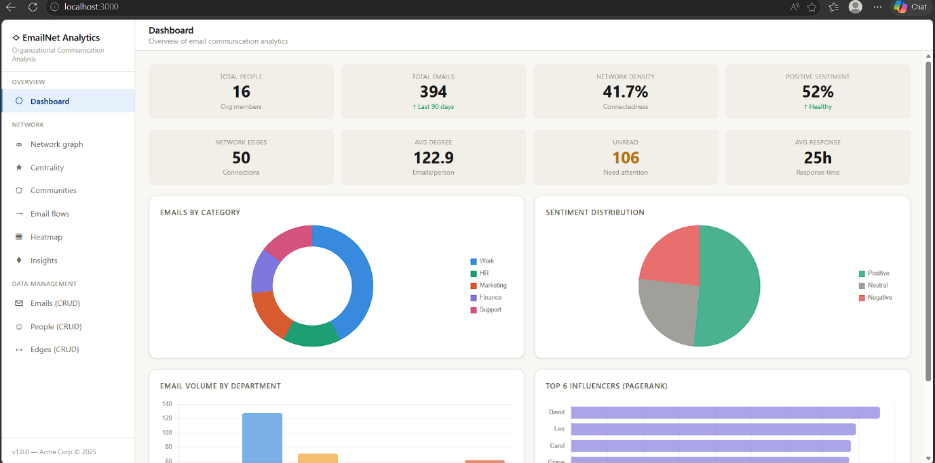
FIG 1: Dashboard of Email Communication Analysis
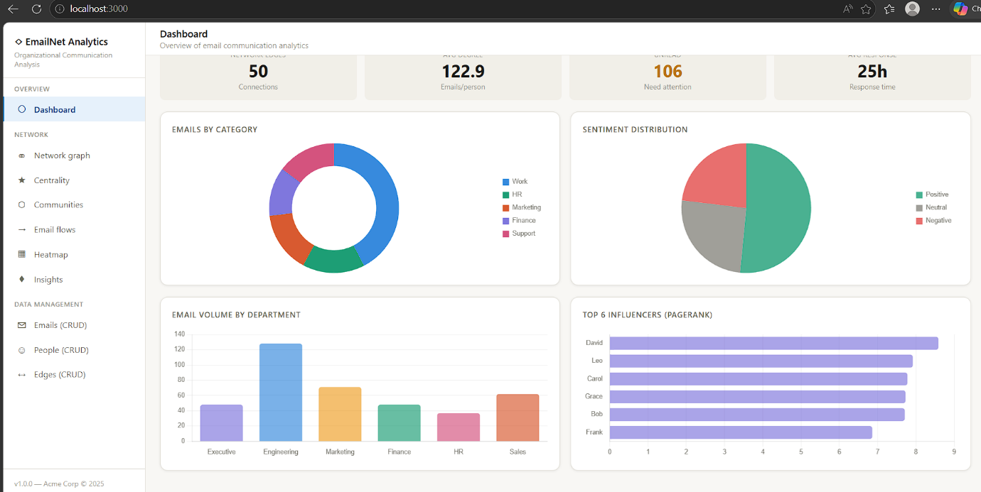

FIG 2: Volume Separation in dashboard

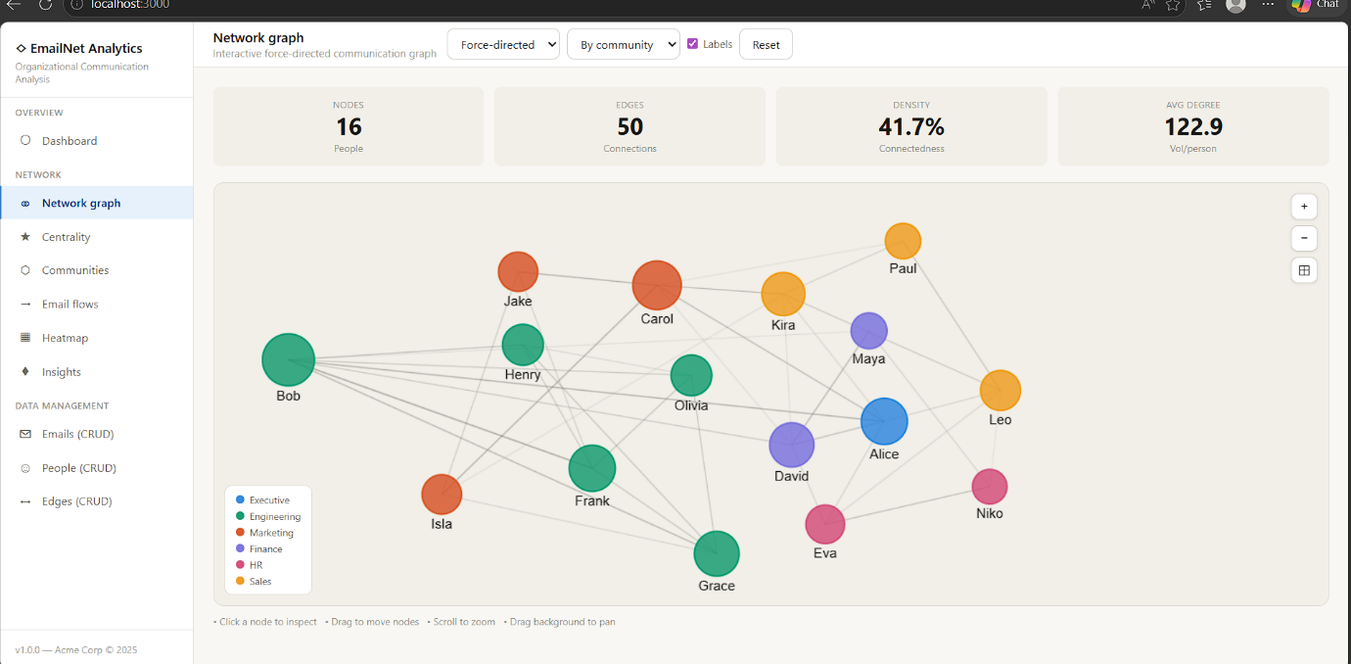
FIG 3: Network Graph Analysis
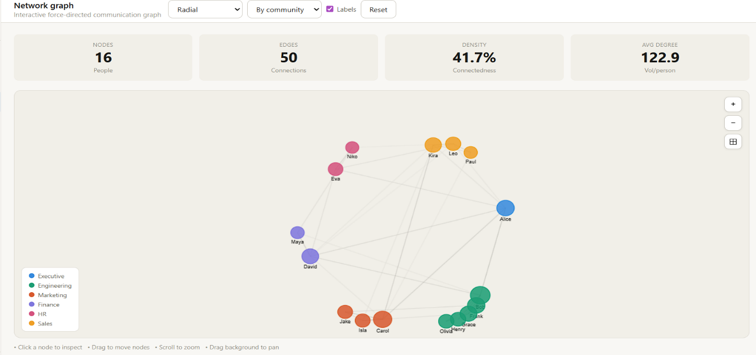

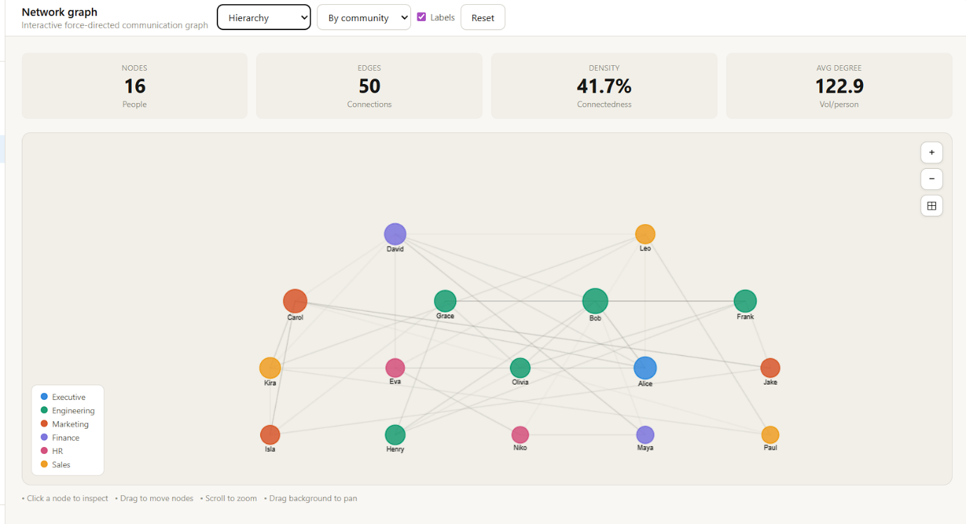

FIG 5: Hierarch Analysis od Email Communication Network Analysis

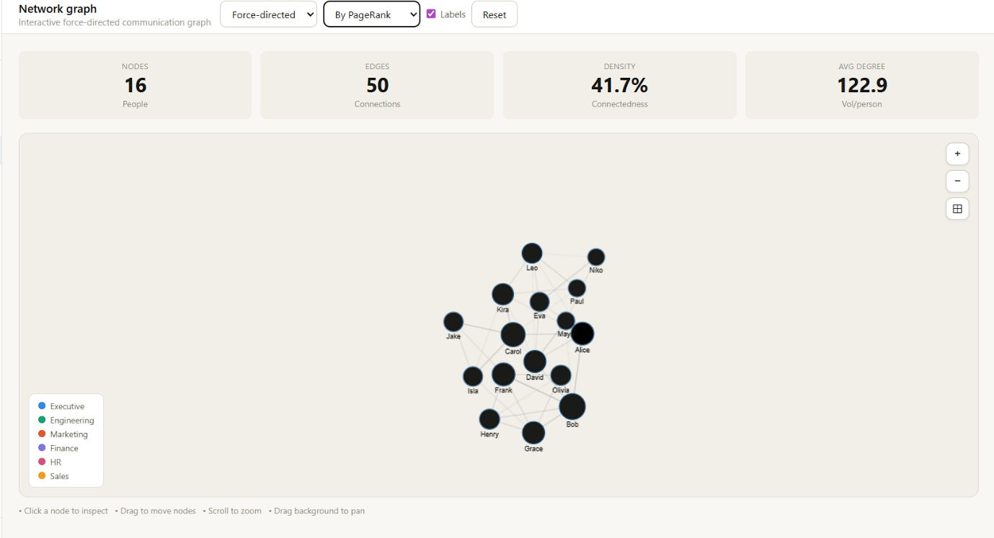

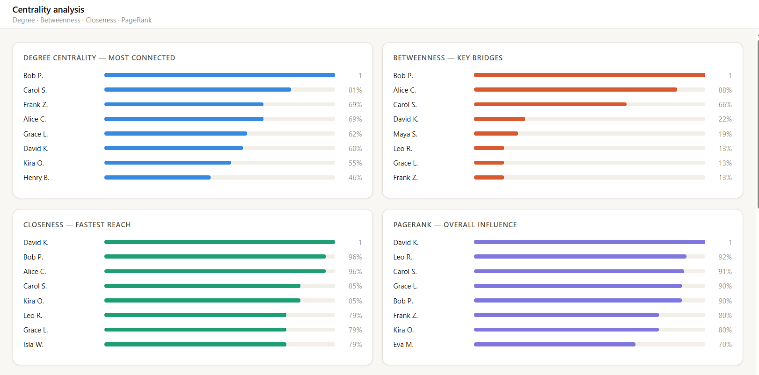
FIG 6: Centrality Analysis
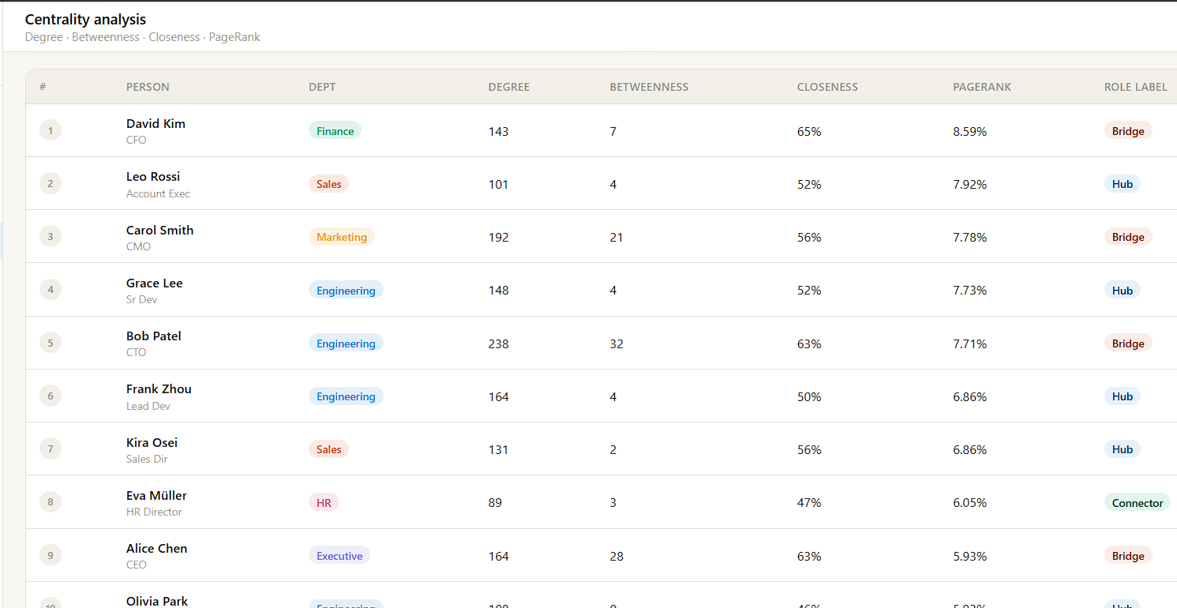

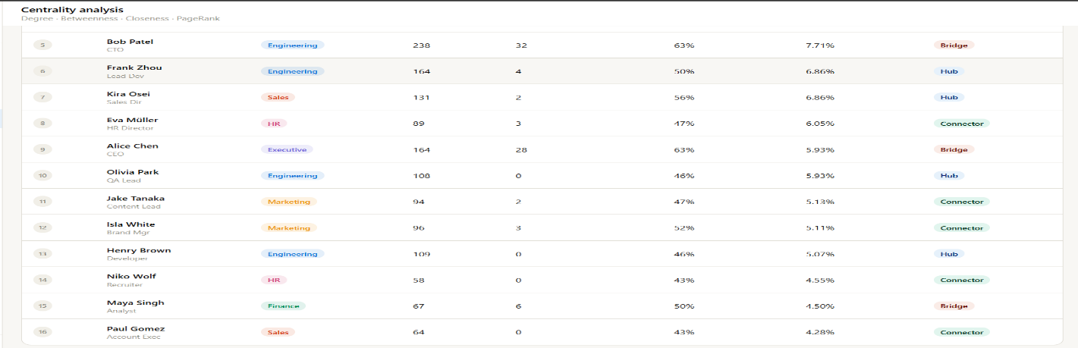
Centrality measures are calculated to identify important nodes in the network.
The following metrics are used:
• Degree Centrality (number of connections)
• Betweenness Centrality (bridge nodes)
• Closeness Centrality (reachability of nodes)
These measures help in identifying key individuals in communication flow.
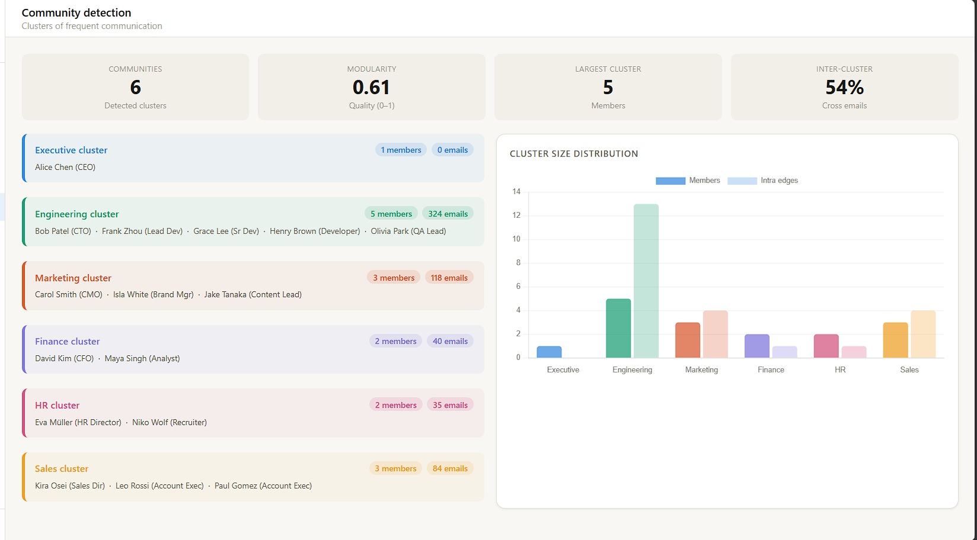
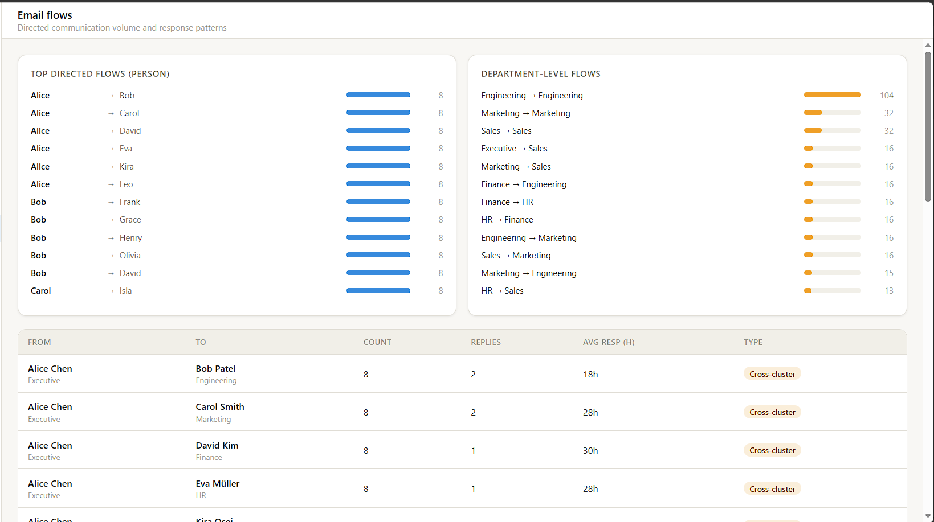
FIG 7: Community Detection

FIG 8: Email Flows
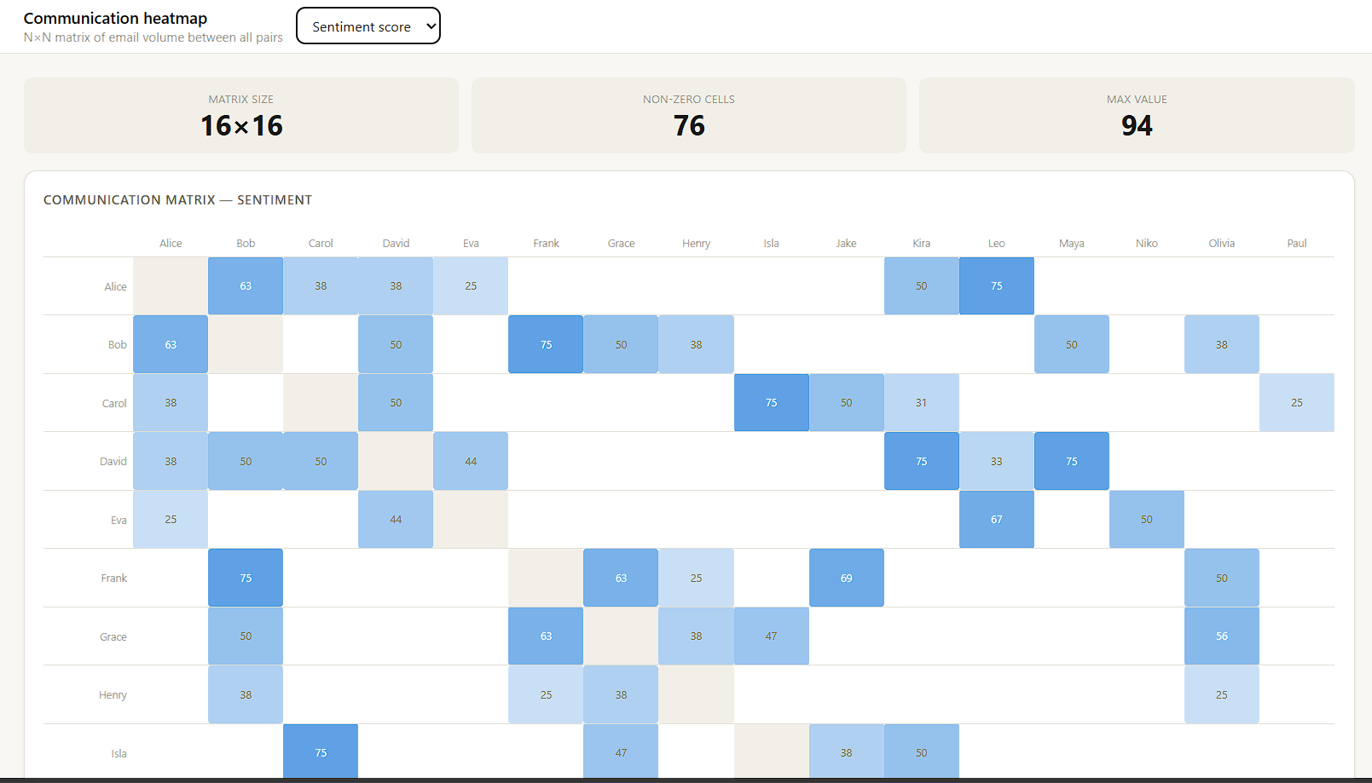
FIG 9: Communication Heatmap

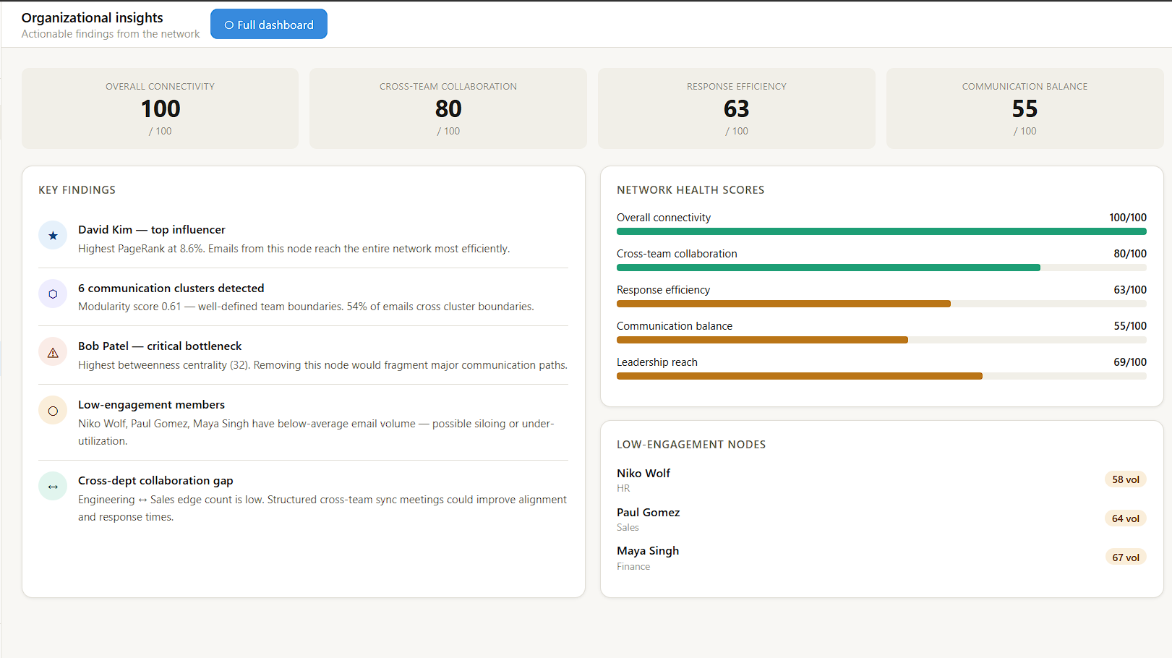
FIG 10: Organizational Insights

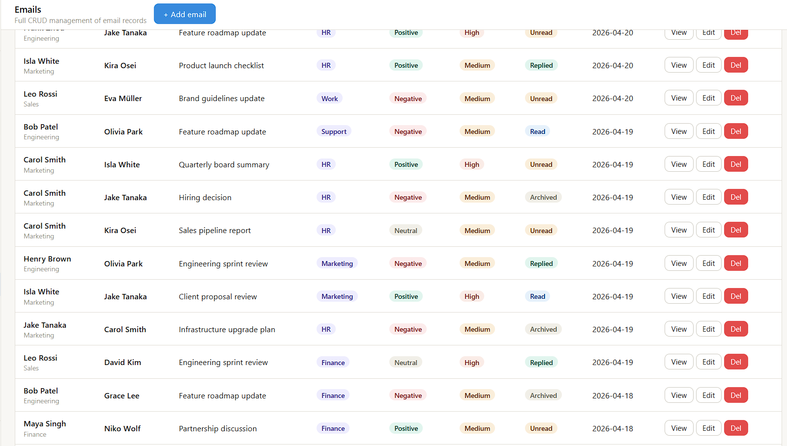
FIG 11: CRUD Operation in Email

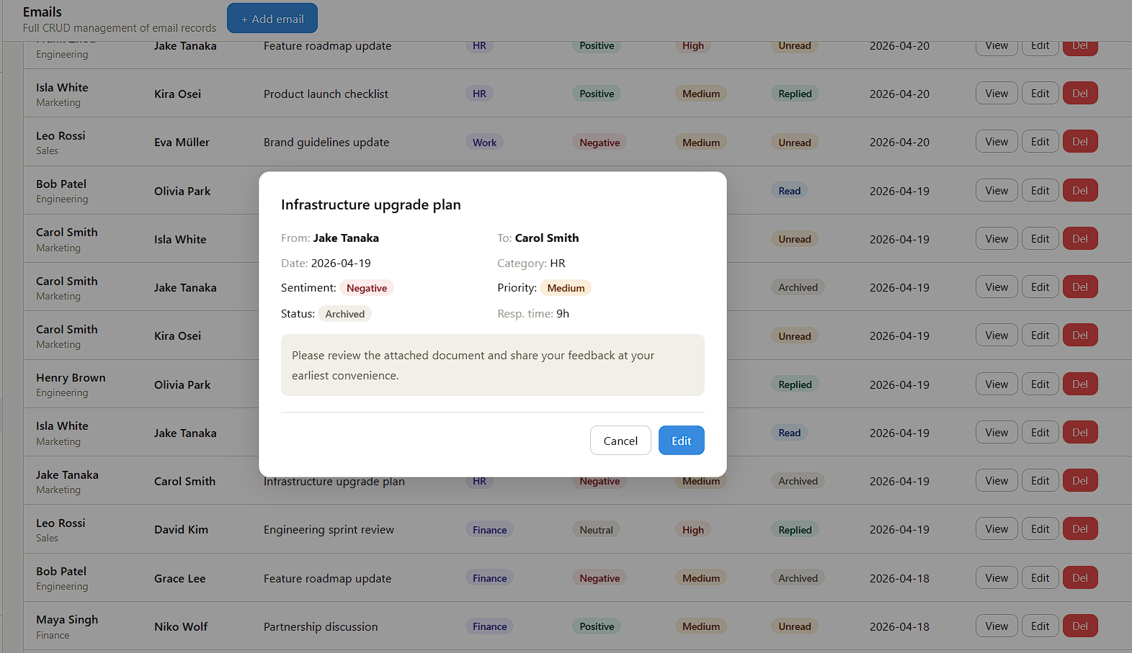
FIG 12 : Edit Option Email Management

The output represents the email communication network constructed from the dataset, where individuals are visualized as nodes and their email interactions are represented as connections (edges). The network graph clearly illustrates how communication flows between different individuals within the organization.
The analysis highlights key nodes that have a higher number of connections, indicating that these individuals play a central role in communication. These central nodes are responsible for a significant portion of information exchange and act as important connectors within the network.
The graph also reveals communication clusters where certain groups of individuals interact more frequently with each other. This indicates the presence of team-based or department-level communication patterns.
Additionally, some nodes appear less connected or isolated, suggesting limited interaction with others. This may indicate communication gaps or individuals who are less involved in the network.
Overall, the model successfully captures the structure of organizational communication and provides a clear visualization of interaction patterns. The results help in understanding communication flow, identifying key contributors, and improving collaboration within the organization.
RESULT:
The developed system successfully performs network analysis on email communication data and provides meaningful insights into organizational communication patterns. The analysis of the dataset indicates clear communication structures, where certain individuals emerge as highly connected nodes based on centrality measures. These nodes represent key communicators who play a major role in information exchange within the organization.
The centrality analysis, particularly degree centrality, highlights individuals with a high number of direct connections, indicating their active involvement in communication. Betweenness centrality further identifies nodes that act as bridges between different groups, facilitating the flow of information across the network. Closeness centrality shows how efficiently certain individuals can reach others, reflecting their importance in rapid information dissemination.
The communication flow analysis reveals the presence of clusters within the network, indicating group-based or departmental communication patterns. These clusters demonstrate how individuals are organized into smaller communication groups while still being connected to the larger network. Additionally, the analysis helps in identifying less connected or isolated nodes, which may indicate limited participation in communication.
The network visualization effectively represents the structure of communication, making it easier to interpret relationships and interaction patterns. The graphical representation clearly shows connections between individuals, highlighting both strong and weak links within the network.
Overall, the system provides accurate analysis of communication structures, effective visualization of interaction patterns, and meaningful insights into organizational communication. These results help in identifying key individuals, improving collaboration, and supporting better decision-making within the organization.
FUTURE ENHANCEMENT:
The current system can be further improved by incorporating advanced machine learning and graph-based techniques such as Graph Neural Networks (GNNs), which are more suitable for analyzing complex network structures. These models can capture deeper relationships between nodes and improve the accuracy of identifying influential individuals and communication patterns compared to basic centrality measures.
Real-time data integration can also be added by connecting the system to live email servers or communication platforms, allowing users to analyze ongoing communication patterns dynamically. This would enable organizations to monitor communication flow in real time and take immediate actions when necessary.
Additionally, the system can be enhanced by supporting multi-level analysis, enabling users to analyze communication at different levels such as individual, team, and department. This would help in understanding both micro-level and macro-level communication structures within the organization.
The user interface can also be improved by adding interactive dashboards and customizable visualizations, allowing users to explore the network dynamically. Features such as zooming, filtering nodes, and highlighting key individuals would enhance usability and user experience.
Furthermore, incorporating sentiment analysis on email content can help in understanding the nature of communication, whether it is positive, neutral, or negative. This can provide additional insights into team dynamics and organizational behavior.
These enhancements would make the system more robust, scalable, and closer to real-world organizational analytics tools, improving both accuracy and practical applicability.

Git Hub Link for the project
GitHub Link | https://github.com/BARATH0202/Email-Communication-Network-Analysis.git

REFERENCES:
- Python Software Foundation. Python Documentation.
Available at: https://docs.python.org/
- Wes McKinney (2010). Data Structures for Statistical Computing in Python.
Proceedings of the 9th Python in Science Conference.
- Pandas Development Team. Pandas Documentation: Python Data Analysis Library.
Available at: https://pandas.pydata.org/docs/
- NetworkX Developers. NetworkX Documentation: Network Analysis in Python.
Available at: https://networkx.org/documentation/stable/
- Kaggle. Email Communication Dataset / Network Analysis Datasets.
Available at: https://www.kaggle.com/
- Newman, M. E. J. (2010). Networks: An Introduction.
Oxford University Press.
- Scikit-learn Developers. Scikit-learn: Machine Learning in Python.
Available at: https://scikit-learn.org/stable/

